How to automatically upload files

When front stage doesn’t use “input” to upload files, can use “autoIT” to automatically to upload files.

1. Download autoIT from <https://www.autoitscript.com/autoit3/files/beta/autoit/>
2. Open AutoIt v3
3. Open the file which need to be uploaded, drag the “Finder Tool” to “Open” button

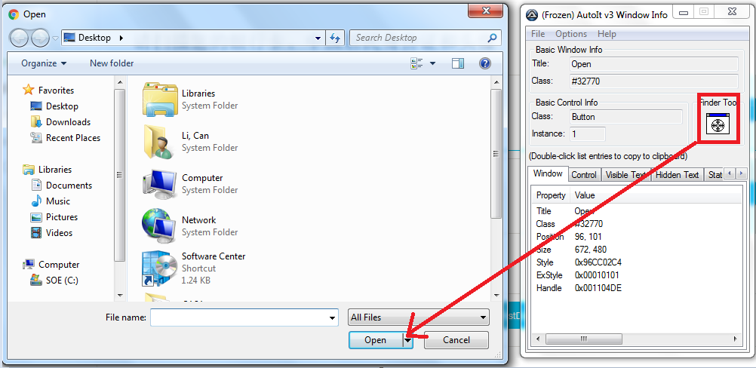

1. Open sci te, input below code

WinActivate("Open ");  
;ControlFocus("title","text",controlID) Edit1=Edit instance 1  
ControlFocus("Open", "","Edit1")

; Wait 10 seconds for the Upload window to appear  
  WinWait("Open","[CLASS:#32770]",10)  
; Set the File name text on the Edit field  
  ControlSetText("打开", "", "Edit1", "C:\Users\Administrator\Desktop\1.jpg")  
 Sleep(2000)  
; Click on the Open button  
  ControlClick("Open ", "","Button1");

1. Save the.au3 file, then click Tools->Build

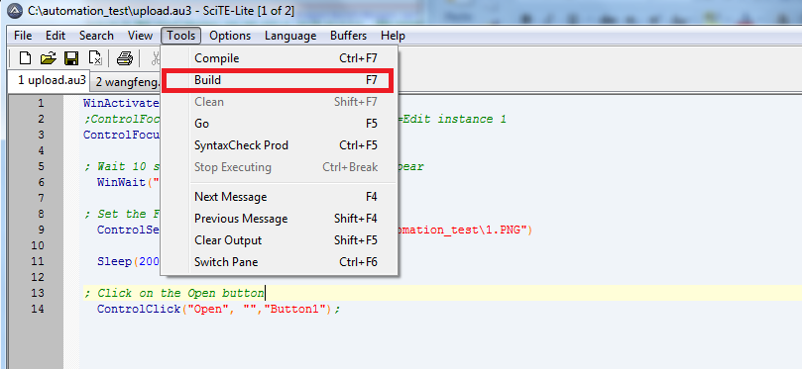

1. Open the Aut2Exe v3, convert .au3 to .exe

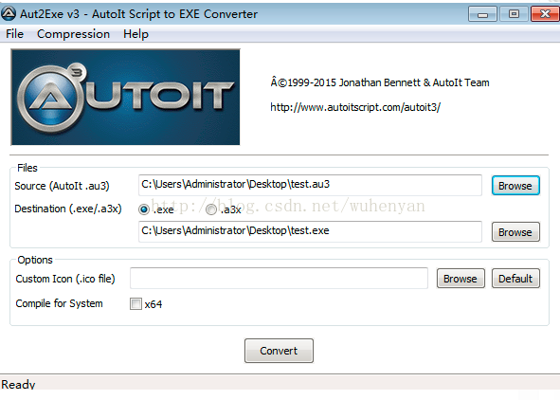

1. Invoke the .exe

